**JSON Best Practices:**

1. Should use proper JSON structure while writing JSON

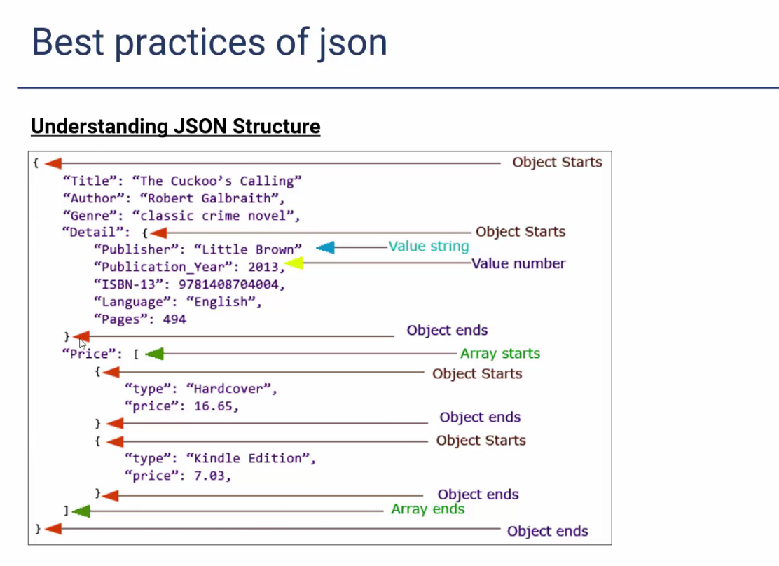

1. Must use suitable JSON data types
2. Careful about bad special characters and handle them smartly

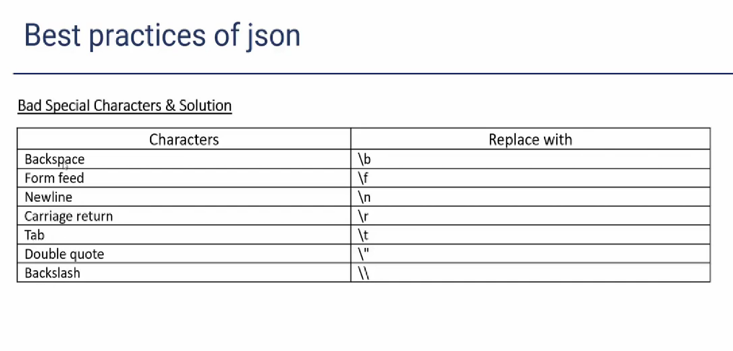

1. Use key-value format
2. Always create a root element